

SIMATS ENGINEERING
Department of Information Technology
CSA07 – Computer Networks
ASSIGNMENT 2 – CO2

Configure, Calculate and Evaluate IP Addressing, Subnetting and Routing for Hospital, Campus, ISP and Smart-City Networks
Packet switching, IPv4 addressing, subnetting, distance-vector and link-state routing, multicast, ICMP, IPv6, software-defined networking, network virtualisation and OpenFlow
Student Name | Y. Naga Giridhar | Register Number | 192572124
Department | B.E-CSE(AI) | Academic Year | 2026-2027
Faculty Name | Dr. Santhiya Lakshmi K | Nature of Assignment | Individual
Duration | 1 Week | Total Marks | 50
Date of Submission |  | Date of Evaluation
Simulation Tool | Cisco Packet Tracer + Python 3 | GitHub Repository | https://github.com/192572124simats-77/CSA0707-CN

Student Signature | Faculty Signature | Program Director

Q1 – Spot the Invalid Addresses 6 Marks
Ans:

1. Method
For a prefix /n the subnet mask has n ones. The “interesting” octet is the one where the mask is neither 255 nor 0; the block size is 256 − (mask value in that octet). The network address is the largest multiple of the block size that does not exceed the address in that octet, the broadcast address is the next block start minus 1, and the usable hosts lie between them (network + 1 … broadcast − 1). A host address must be neither the network nor the broadcast address.

2. Calculations
Table 1: Network, broadcast and usable range of the four devices
Device | Address/prefix  (mask) | Block size | Network | Broadcast | Usable hosts (count) | Valid host?
Admission PC | 172.16.45.200/20  255.255.240.0 | 16 in 3rd octet; 45 lies in 32–47 | 172.16.32.0 | 172.16.47.255 | 172.16.32.1 – 172.16.47.254  (4094) | Yes
Lab printer | 10.0.15.255/21  255.255.248.0 | 8 in 3rd octet; 15 lies in 8–15 | 10.0.8.0 | 10.0.15.255 | 10.0.8.1 – 10.0.15.254  (2046) | NO – it is the broadcast address
X-ray server | 192.168.4.0/23  255.255.254.0 | 2 in 3rd octet; 4 lies in 4–5 | 192.168.4.0 | 192.168.5.255 | 192.168.4.1 – 192.168.5.254  (510) | NO – it is the network address
Clinic router | 203.0.113.10/29  255.255.255.248 | 8 in 4th octet; 10 lies in 8–15 | 203.0.113.8 | 203.0.113.15 | 203.0.113.9 – 203.0.113.14  (6) | Yes

The two traps
- Trap 1 – Lab printer 10.0.15.255/21. It looks like an ordinary host because its last octet is 255, but in a /21 the host part is the last 11 bits and 15.255 = 00001111.11111111, so all host bits are 1: it is the directed broadcast address of 10.0.8.0/21. A device cannot own it; frames sent to it are treated as broadcasts, so the printer cannot be reached. Fix: use any address from 10.0.8.2 – 10.0.15.254, e.g. 10.0.8.50.
- Trap 2 – X-ray server 192.168.4.0/23. The 0 in the last octet looks harmless, but with a /23 the host part spans the last 9 bits and 4.0 = 00000100.00000000, so all host bits are 0: it is the network address of 192.168.4.0/23 (it identifies the subnet, not a host). Operating systems and routers reject or mis-handle it. Fix: 192.168.4.10 (the gateway 192.168.4.1 is valid and inside the subnet).
The other two devices are valid. For the Admission PC the 200 in the last octet is irrelevant because the 3rd octet (45) is not at a block boundary (45 is not 47) and the host part is not all ones; its gateway 172.16.32.1 is inside 172.16.32.0/20. The clinic router has 6 usable addresses; note that 203.0.113.0/24 is the reserved documentation range (TEST-NET-3), so in a real deployment the provider’s block would be different, but the arithmetic is identical. The 18 devices cannot each have a public address because a /29 offers only 6 usable ones, which is why the clinic “has run out of addresses”.
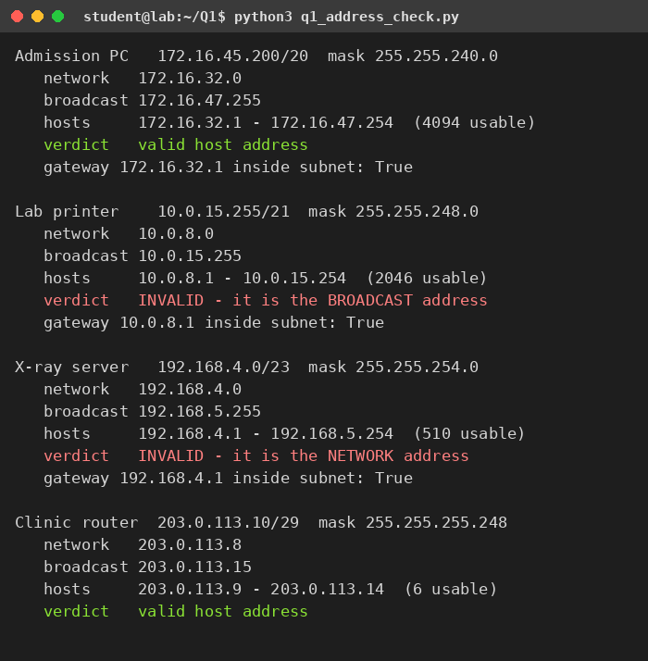
Figure 1: Output of q1_address_check.py (checked with Python’s ipaddress module)

3. Inquiry – NAT and packet switching

3.1 How two PCs can both use source port 50000
The clinic uses PAT (NAT overload): all 18 inside devices share one public address, 203.0.113.9 (the other usable addresses stay free for the router and servers). A NAT table entry is identified by the whole tuple (inside IP, inside port, destination) and is mapped to a unique outside port. Two PCs may pick the same source port, but the router translates them to different outside ports, so replies can be told apart.
Table 2: PAT table on the clinic router (both PCs contact the server 198.51.100.10:443)
Inside local (PC:port) | Inside global (public:port) | Outside (server) | Protocol
192.168.1.11 : 50000 | 203.0.113.9 : 40001 | 198.51.100.10 : 443 | TCP
192.168.1.12 : 50000 | 203.0.113.9 : 40002 | 198.51.100.10 : 443 | TCP

Outbound: a packet 192.168.1.12:50000 → 198.51.100.10:443 leaves as 203.0.113.9:40002 → 198.51.100.10:443. Inbound: a reply addressed to 203.0.113.9:40002 is looked up in the table and rewritten to 192.168.1.12:50000, so PC 2 (and not PC 1) receives it. One public address offers roughly 64,000 outside ports, so 18 devices are far below the limit.
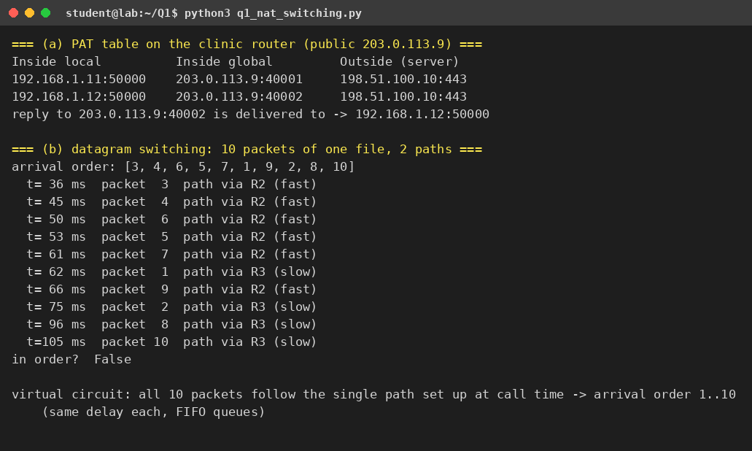
Figure 2: PAT table and datagram-switching simulation (q1_nat_switching.py)

3.2 Why packets of one file can arrive out of order (datagram switching)
In datagram switching (the IP model) every packet carries the full destination address and is routed independently by each router, with no connection set up. If two paths exist (or the routing table changes, or a queue is longer on one path), consecutive packets of one file can take different paths with different delays. In the simulation, ten packets sent 5 ms apart over a fast path (about 20 ms) and a slow path (about 55 ms) arrive as 3, 4, 6, 5, 7, 1, 9, 2, 8, 10. TCP repairs this with sequence numbers and a reordering buffer, at the cost of extra delay (and unnecessary duplicate ACKs).

3.3 What virtual circuits change
Table 3: Datagram switching compared with virtual-circuit switching
Aspect | Datagram (IP) | Virtual circuit (ATM, Frame Relay, MPLS LSP)
Set-up | None – the first packet can be sent at once | Call set-up before data; path and a circuit identifier are stored in every switch
Path / ordering | Each packet routed separately → reordering possible | One path for the whole call → packets arrive in order
Header | Full destination address (20 B IPv4 / 40 B IPv6) | Short circuit number (e.g. 2–4 B label)
Failure | Next packet is simply routed around the failure | Circuit breaks and must be re-established; state is lost
Resources / QoS | Hard to guarantee; best effort | Bandwidth/buffers can be reserved per circuit
Switch state | Stateless forwarding (routing table only) | Per-connection state in every switch

Judgement: for the clinic’s mixed traffic (web, email, cloud records) datagram switching is the better fit because it needs no set-up and survives link failures; reordering is a small cost handled by TCP. Virtual circuits are justified only for real-time flows such as a tele-radiology video call, where ordering and guaranteed bandwidth matter – and that is exactly where MPLS is used in provider networks.

4. Alternative Concept Analysis – a public /27 instead of NAT behind a /29
Addresses needed. 18 devices plus 1 router interface (the gateway) = 19 addresses. Smallest block: 19 + 2 (network and broadcast) = 21 ≤ 32, so a /27 (32 addresses, 30 usable). A /28 has only 14 usable addresses and is too small.
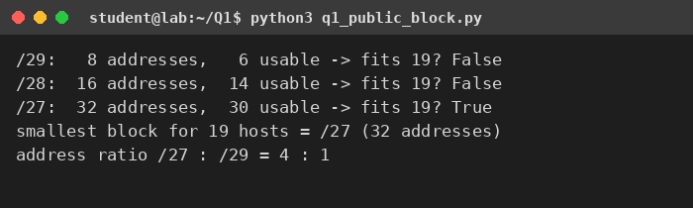
Figure 3: Output of q1_public_block.py
Table 4: NAT behind a /29 versus a public /27
Measure | /29 + PAT (original) | Public /27 (alternative)
Public addresses consumed | 8 (6 usable; in practice 1 used for PAT) | 32 (30 usable; 19 used, 11 spare)
Cost | 1× (lease cost ≈ number of addresses × price per address) | 4× the address lease, because 32 ÷ 8 = 4
Exposure to the internet | Only the router is visible; inside hosts cannot be reached unless a port-forward is added (a side effect of NAT, not a firewall) | All 18 devices are directly reachable and scannable → a firewall with strict rules is mandatory; larger attack surface (X-ray and lab devices are sensitive)
End-to-end connectivity | Broken: inbound connections, port forwarding needed | Restored: every device has its own routable address
Router work | Translation state per flow, CPU and memory | Plain forwarding; no table to exhaust
Reliability | Port exhaustion / table timeouts can drop sessions | No translation state to lose

Application problems NAT would no longer cause: inbound services (a PACS/DICOM or remote-radiology server reachable from outside without port forwarding); protocols that carry IP addresses inside the payload (active-mode FTP, SIP/VoIP, H.323) and need ALGs; IPsec in AH mode and some VPNs that fail through NAT; peer-to-peer and tele-consultation sessions that need hole-punching; per-device logging and accountability (with PAT every log line shows the same public IP); and port-exhaustion drops.
Decision. The clinic’s devices are mostly clients, so the original /29 with PAT plus a firewall is cheaper and safer. A public /27 is justified only if several devices must accept inbound connections or use AH-based VPNs; even then it is better to publish just those servers through static NAT, and plan IPv6 for the long term, where every device gets a global address without NAT.

Q2 – Subnet a Campus That Keeps Growing 8 Marks
Ans:

1. Plan A – equal-size subnets
Four subnets are needed, so the /24 is cut into 2² = 4 equal parts of /26 (64 addresses, 62 usable hosts each).
Table 5: Equal-size plan (mask of every subnet 255.255.255.192)
Subnet | Network/prefix | Hosts needed | First host | Last host | Broadcast | Result
Labs | 192.168.10.0/26 | 100 | 192.168.10.1 | 192.168.10.62 | 192.168.10.63 | FAILS – 62 < 100 (short by 38)
Staff | 192.168.10.64/26 | 50 | 192.168.10.65 | 192.168.10.126 | 192.168.10.127 | Fits, 12 wasted
Library | 192.168.10.128/26 | 25 | 192.168.10.129 | 192.168.10.190 | 192.168.10.191 | Fits, 37 wasted
WAN link | 192.168.10.192/26 | 2 | 192.168.10.193 | 192.168.10.254 | 192.168.10.255 | Fits, 60 wasted

Evaluation. Equal-size subnetting cannot satisfy the requirement. The Labs need 100 hosts, which needs a /25 (126 hosts), but a /24 holds only two /25s, so four equal subnets of that size do not exist. With /26s the Labs are 38 hosts short, and the other three subnets waste 12 + 37 + 60 = 109 addresses (the WAN link wastes 60 of its 62 addresses). Equal sizes are therefore both too small for the largest department and wasteful for the smallest.

2. Plan B – VLSM
For every requirement the block is the smallest power of two that is ≥ hosts + 2 (network and broadcast): Labs 102 → 128 (/25); Staff 52 → 64 (/26); Library 27 → 32 (/27); WAN 4 → 4 (/30). Blocks are placed largest first, each starting where the previous one ended.
Table 6: VLSM plan for 192.168.10.0/24
Subnet | Network/prefix | Mask | First host | Last host | Broadcast
Labs | 192.168.10.0/25 | 255.255.255.128 | 192.168.10.1 | 192.168.10.126 | 192.168.10.127
Staff | 192.168.10.128/26 | 255.255.255.192 | 192.168.10.129 | 192.168.10.190 | 192.168.10.191
Library | 192.168.10.192/27 | 255.255.255.224 | 192.168.10.193 | 192.168.10.222 | 192.168.10.223
WAN link | 192.168.10.224/30 | 255.255.255.252 | 192.168.10.225 | 192.168.10.226 | 192.168.10.227

The plan allocates 128 + 64 + 32 + 4 = 228 addresses; 28 addresses (192.168.10.228 – .255) remain. Usable capacity is 220 hosts for a need of 177, so only 43 usable addresses are unused (against 109 + the Labs failure in Plan A).
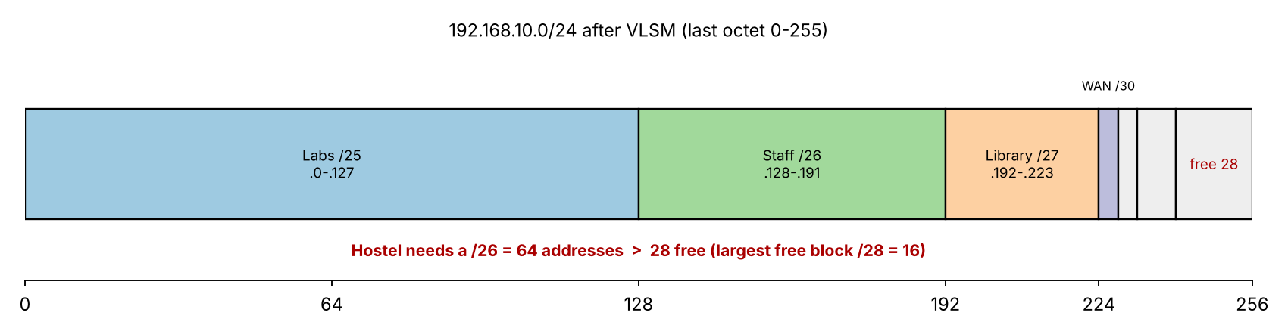
Figure 4: Address map of the VLSM plan; the remaining 28 addresses cannot hold a /26

3. The hostel trap
Can 60 hosts be fitted without renumbering? No. 60 + 2 = 62 ≤ 64, so the hostel needs a /26 (64 addresses). The free space is 192.168.10.228/30, 192.168.10.232/29 and 192.168.10.240/28; the largest free block is a /28 with 16 addresses. Even renumbering cannot help: the blocks needed are 128 + 64 + 64 + 32 + 4 = 292 > 256, so no arrangement of five networks fits in one /24.
Smallest change that makes it fit: give the hostel a /26 from the next /24, 192.168.11.0/26 (hosts 192.168.11.1 – .62, broadcast 192.168.11.63). Nothing is renumbered, and because 192.168.10.0/24 and 192.168.11.0/24 are adjacent, the whole campus is still summarised by one route, 192.168.10.0/23. Options considered:
Table 7: Ways to add the 60-host hostel
Option | Result | Verdict
Use the 28 free addresses | Needs 64, has 28 (largest block /28) | Impossible
Renumber everything inside the /24 | Total need 292 > 256 addresses | Impossible
Use /31 for the WAN link (RFC 3021) | Saves only 2 addresses | Not enough
Hostel /26 from 192.168.11.0/24 (adjacent) | No renumbering; summary 192.168.10.0/23 | Smallest workable change

4. Route summarisation
The third octets are 8, 9, 10, 11 = 00001000 … 00001011. The first 6 bits (000010) are common, so the common prefix is 16 + 6 = 22 bits: 172.16.8.0/22 (covering 172.16.8.0 – 172.16.11.255) replaces four routes with one.
What goes wrong with /21: 172.16.8.0/21 covers third octets 8 – 15, i.e. also 172.16.13.0/24, 172.16.14.0/24 and 172.16.15.0/24, which do not exist. The router advertising the /21 tells the rest of the network “send me everything for 172.16.8.0 – 172.16.15.255”. Packets to the three unused blocks (a mistyped host, a scan, a future site that is attached elsewhere) arrive at the summarising router and are black-holed or, with default routes, bounce back and forth until the TTL expires (a routing loop). A later site that really owns 172.16.13.0/24 elsewhere would be unreachable from outside because the longer /24 is hidden behind the /21 advertisement. Correct options: advertise 172.16.8.0/22 and 172.16.12.0/24 separately, or use the /21 only when all eight blocks are reserved for the same site (and add a discard route to Null0 on the summarising router to avoid loops).
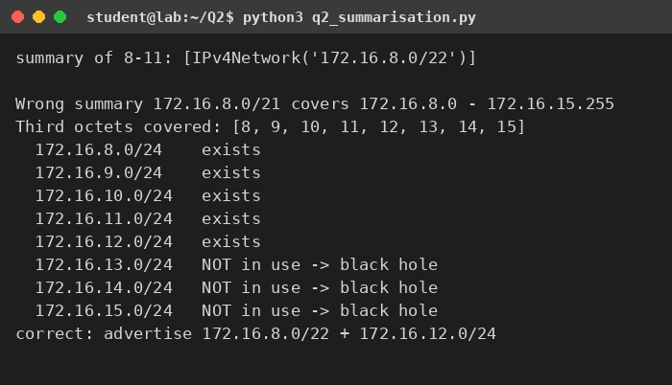
Figure 5: Output of q2_summarisation.py

5. Complete the Code – TODO 1
The following block replaces pass in vlsm(); the rest of the program is unchanged. Each block is also checked with Python’s ipaddress module (the asserts).
def vlsm(base, needs):
addr = to_int(base)
for name, hosts in sorted(needs, key=lambda x: -x[1]):
# TODO 1 (completed)
size = 1
while size < hosts + 2: # smallest power of two >= hosts + 2
size *= 2
prefix = 32 - int(math.log2(size))
assert addr % size == 0, "block is not aligned"
first, last, bcast = addr + 1, addr + size - 2, addr + size - 1
print(f"{name:<10}{to_ip(addr)}/{prefix} hosts {to_ip(first)} - {to_ip(last)} bcast {to_ip(bcast)}")
net = ipaddress.ip_network(f"{to_ip(addr)}/{prefix}") # independent check
assert str(net.broadcast_address) == to_ip(bcast)
assert net.num_addresses - 2 >= hosts
addr += size # move to the next block
return to_ip(addr)

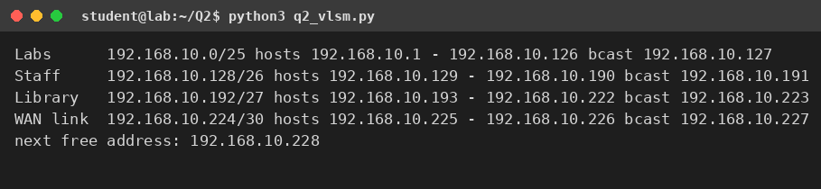
Figure 6: Output of q2_vlsm.py – identical to the expected output (next free address 192.168.10.228)
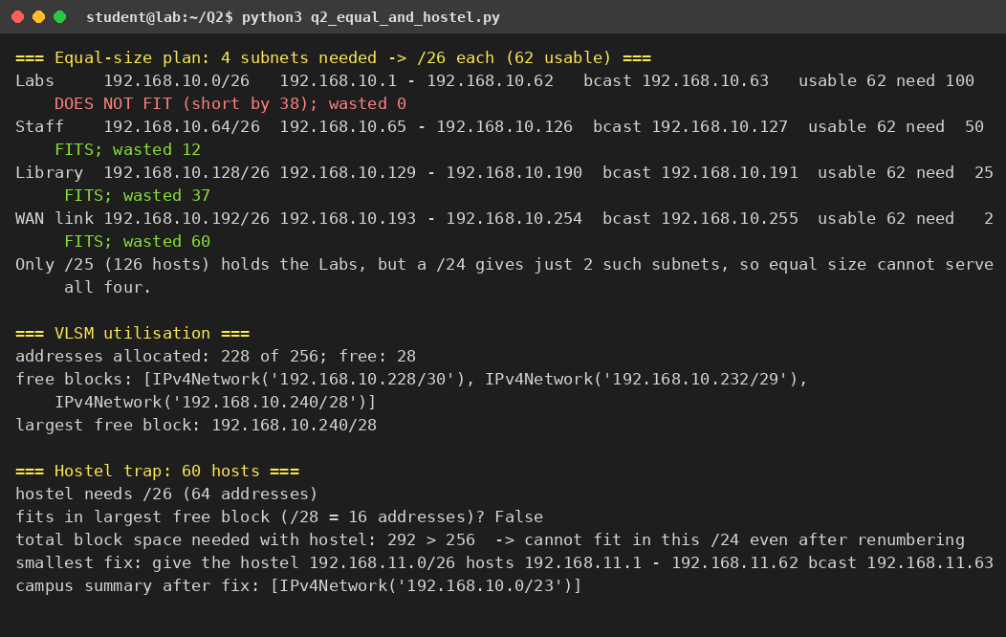
Figure 7: Output of q2_equal_and_hostel.py – equal-size plan, utilisation and the hostel trap

6. Verification in Packet Tracer
Build one router and three LANs: R1 G0/0 = 192.168.10.1/25 (Labs), G0/1 = 192.168.10.129/26 (Staff), G0/2 = 192.168.10.193/27 (Library), S0/0/0 = 192.168.10.225/30 (WAN). PCs: Labs 192.168.10.2/25 (gw .1), Staff 192.168.10.130/26 (gw .129), Library 192.168.10.194/27 (gw .193). Expected: show ip route shows four connected networks (C/L entries) and all three PCs ping each other; a PC given 192.168.10.126 in the Labs (broadcast of the /25 is .127) works, while .127 is refused.

7. Alternative Concept Analysis – smallest subnet first
Allocating in the order WAN (/30), Library (/27), Staff (/26), Labs (/25) and placing each block directly after the previous one gives misaligned, overlapping blocks: after the WAN block ends at 192.168.10.3 the next address is 192.168.10.4, but a /27 must start at a multiple of 32, so “192.168.10.4/27” is really 192.168.10.0/27 and overlaps the WAN link; Staff “192.168.10.36/26” becomes 192.168.10.0/26 and Labs “192.168.10.100/25” becomes 192.168.10.0/25 – all four overlap.
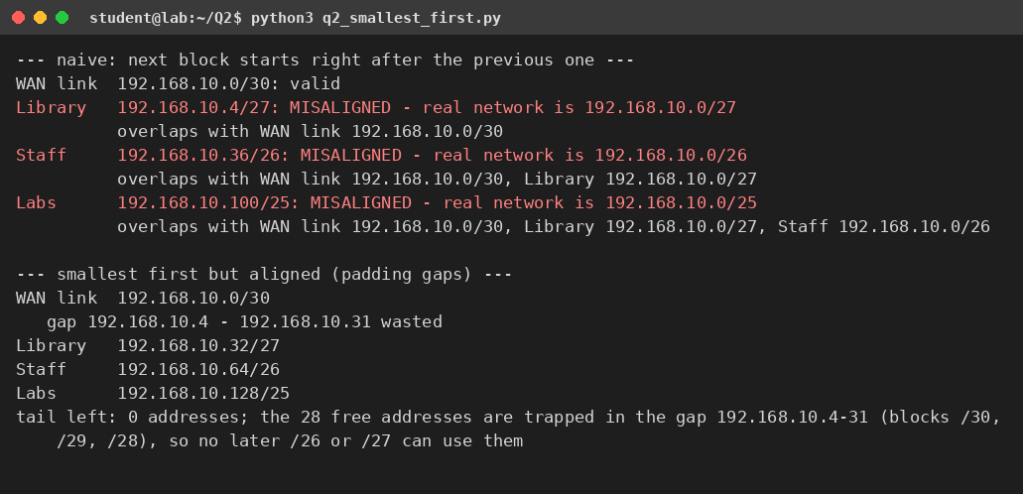
Figure 8: Output of q2_smallest_first.py – naive and aligned smallest-first allocation
If each block is first rounded up to its own boundary, the plan becomes valid (WAN .0/30, Library .32/27, Staff .64/26, Labs .128/25) but 28 addresses (192.168.10.4 – .31) are stranded in a gap that can only be reused as /30, /29 and /28 – too small for the hostel – whereas largest-first leaves one contiguous free tail (192.168.10.228 – .255).
Why largest first: a block of size 2ᵏ must start at an address divisible by 2ᵏ. If blocks are placed in descending size, every start address is a multiple of the sum of larger powers of two, hence divisible by the next (smaller) block size, so no padding, no overlap and no wasted gaps are created. Placing small blocks first misaligns the larger ones that follow.

Q3 – Which Way Will the Packet Go? 6 Marks
Ans:

1. Next hops – the longest-prefix-match rule
Rule: a router collects every route whose prefix contains the destination address and forwards the packet using the most specific (longest-prefix) match; the administrative distance and metric are used only to choose between routes of the same prefix. The default route 0.0.0.0/0 matches everything, so it is used only when nothing else matches.
Table 8: Next hop for each destination
Destination | Routes that contain it | Winner (longest) | Next hop and reason
10.1.2.200 | /8, /16, /24, /25 and the default | 10.1.2.128/25 | 192.0.2.13 – /25 covers 10.1.2.128 – 255 and 200 ≥ 128
10.1.2.100 | /8, /16, /24 and the default | 10.1.2.0/24 | 192.0.2.9 – 100 < 128, so the /25 does not contain it
10.1.9.9 | /8, /16 and the default | 10.1.0.0/16 | 192.0.2.5 – third octet 9 is outside 10.1.2.0/24
10.7.7.7 | /8 and the default | 10.0.0.0/8 | 192.0.2.1 – only the /8 is more specific than the default
8.8.8.8 | default only | 0.0.0.0/0 | 198.51.100.1 – gateway of last resort (S*)

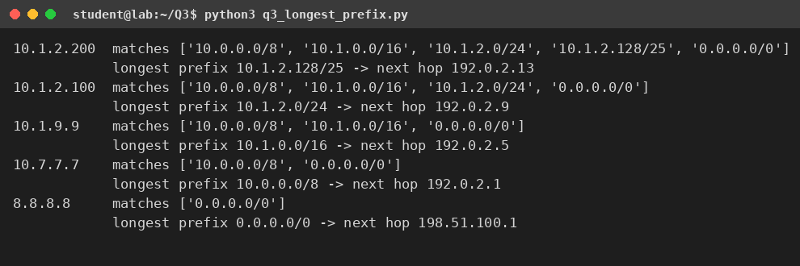
Figure 9: Output of q3_longest_prefix.py

2. Two-campus network in Packet Tracer
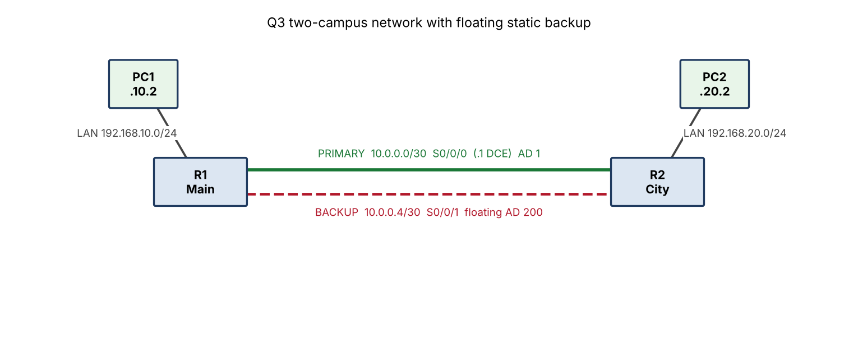
Figure 10: Topology: R1 (Main campus) and R2 (City campus) with a primary and a floating-static backup link
Table 9: Addressing table
Device | Interface | IP address | Mask | Gateway
R1 | G0/0 | 192.168.10.1 | 255.255.255.0 | –
R1 | S0/0/0 (DCE, primary) | 10.0.0.1 | 255.255.255.252 | –
R1 | S0/0/1 (DCE, backup) | 10.0.0.5 | 255.255.255.252 | –
R2 | G0/0 | 192.168.20.1 | 255.255.255.0 | –
R2 | S0/0/0 (primary) | 10.0.0.2 | 255.255.255.252 | –
R2 | S0/0/1 (backup) | 10.0.0.6 | 255.255.255.252 | –
PC1 (Main) | NIC | 192.168.10.2 | 255.255.255.0 | 192.168.10.1
PC2 (City) | NIC | 192.168.20.2 | 255.255.255.0 | 192.168.20.1

Complete the Code – R1 (TODO 1 and TODO 2 completed, floating static added)
! Cisco Packet Tracer - R1 (Main campus), TODO 1 and TODO 2 completed + floating static backup
enable
configure terminal
hostname R1
interface GigabitEthernet0/0
ip address 192.168.10.1 255.255.255.0
no shutdown
! TODO 1: Serial0/0/0 = DCE end, 10.0.0.1/30, clock rate 64000
interface Serial0/0/0
ip address 10.0.0.1 255.255.255.252
clock rate 64000
no shutdown
exit
! backup link (Serial0/0/1) for the floating static route
interface Serial0/0/1
ip address 10.0.0.5 255.255.255.252
clock rate 64000
no shutdown
exit
! TODO 2: primary static route to the City campus LAN
ip route 192.168.20.0 255.255.255.0 10.0.0.2
! floating static route, administrative distance 200 (used only if the primary disappears)
ip route 192.168.20.0 255.255.255.0 10.0.0.6 200
end
write memory
show ip route

R2 – reverse routes
! Cisco Packet Tracer - R2 (City campus): reverse routes
enable
configure terminal
hostname R2
interface GigabitEthernet0/0
ip address 192.168.20.1 255.255.255.0
no shutdown
interface Serial0/0/0
ip address 10.0.0.2 255.255.255.252
no shutdown
interface Serial0/0/1
ip address 10.0.0.6 255.255.255.252
no shutdown
exit
ip route 192.168.10.0 255.255.255.0 10.0.0.1
ip route 192.168.10.0 255.255.255.0 10.0.0.5 200
end
write memory
show ip route

TODO 1: the serial interface gets 10.0.0.1 255.255.255.252, clock rate 64000 (R1 is the DCE end that supplies the clock) and no shutdown. TODO 2: ip route 192.168.20.0 255.255.255.0 10.0.0.2 – a static route to the City LAN through the next hop 10.0.0.2. The floating route uses the same destination and the higher administrative distance 200 (a static route normally has AD 1), so it stays hidden in the configuration until the primary route disappears.

Expected results (compare with your Packet Tracer output)
Table 10: Routing table of R1 before and after the main link is shut down
State | show ip route (relevant lines) | Result
Before (both links up) | S 192.168.20.0/24 [1/0] via 10.0.0.2  C 10.0.0.0/30 is directly connected, Serial0/0/0  C 10.0.0.4/30 is directly connected, Serial0/0/1 | Ping PC1 → PC2 succeeds via the primary link; the floating route [200/0] is not shown.
After interface Serial0/0/0 → shutdown | S 192.168.20.0/24 [200/0] via 10.0.0.6  C 10.0.0.4/30 is directly connected, Serial0/0/1 | The primary route is withdrawn (its next hop is no longer reachable), the floating route is installed and ping succeeds again after a few seconds.
After no shutdown | S 192.168.20.0/24 [1/0] via 10.0.0.2 | Traffic returns to the primary link because AD 1 beats AD 200.

Removing the clock rate on the DCE end
Expected observation (record and screenshot your own): a serial link needs a clock from the DCE end. Without clock rate, the line protocol cannot come up, so show ip interface brief shows Serial0/0/0 as down (the line protocol is down, and in Packet Tracer the link shows red markers). The connected network 10.0.0.0/30 disappears from the routing table, the static route via 10.0.0.2 is withdrawn because its next hop is no longer reachable, and PC1 cannot ping PC2 (or, with the floating route in place, traffic moves to the backup). Restoring clock rate 64000 brings the link and the route back.

3. Alternative Concept Analysis – OSPF instead of static routes
Assumptions: every campus router must reach every other campus LAN; the campuses are joined in a ring; a static route is one line per destination (the floating backup doubles it); with OSPF each router needs router ospf 1 plus one network line for its LAN and for each of its two links.
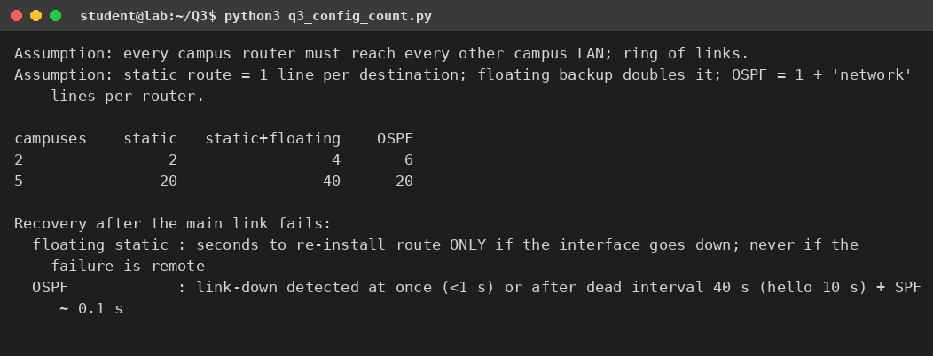
Figure 11: Output of q3_config_count.py
Table 11: Configuration lines needed
Campuses | Static routes | Static with floating backups | OSPF
2 | 2 | 4 | 6
5 | 20 | 40 | 20

- Growth: static configuration grows as N × (N − 1) (quadratic); OSPF grows linearly (about 4 lines per router). With 2 campuses static is simpler (2 lines against 6); the lines are equal at 5 campuses without backups and OSPF is half of static with backups.
- Recovery when the main link fails: a floating static route recovers as soon as the router sees its outgoing interface go down (seconds); but if the failure is in the middle of the path and the local interface stays up, the static route is never withdrawn and traffic is black-holed unless IP SLA tracking is added. OSPF detects the loss when the interface fails (under a second) or, otherwise, after the dead interval of 40 s (hello 10 s), then runs SPF (milliseconds) and installs the alternative path automatically – and it can do this for any failure, not just a local one.
- Judgement: use static (with floating backup) for two campuses and a stub link; move to OSPF from about five campuses, or whenever remote failures must be detected automatically. OSPF costs more CPU/memory, needs authentication and timer tuning, but removes the manual edits that cause mistakes.

Q4 – Watch Distance-Vector Routing Count to Infinity 6 Marks
Ans:

1. Round-by-round distance tables
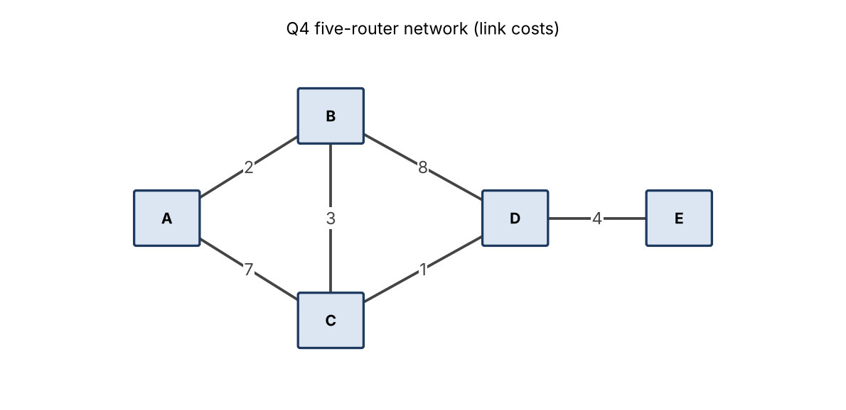
Figure 12: The five-router network with its link costs
Each router starts knowing only its direct links. In every round all routers send their current vectors at the same time, and each router applies the Bellman-Ford rule D(u,dest) = min over neighbours n of [ cost(u,n) + D(n,dest) ] using the vectors received in that round (value 99 = unreachable).
Table 12: Round 0 – only direct links known
 | A | B | C | D | E
A | 0 | 2 | 7 | ∞ (99) | ∞ (99)
B | 2 | 0 | 3 | 8 | ∞ (99)
C | 7 | 3 | 0 | 1 | ∞ (99)
D | ∞ (99) | 8 | 1 | 0 | 4
E | ∞ (99) | ∞ (99) | ∞ (99) | 4 | 0

Table 13: Distance tables after round 1
 | A | B | C | D | E
A | 0 | 2 | 5 | 8 | ∞ (99)
B | 2 | 0 | 3 | 4 | 12
C | 5 | 3 | 0 | 1 | 5
D | 8 | 4 | 1 | 0 | 4
E | ∞ (99) | 12 | 5 | 4 | 0

Table 14: Distance tables after round 2
 | A | B | C | D | E
A | 0 | 2 | 5 | 6 | 12
B | 2 | 0 | 3 | 4 | 8
C | 5 | 3 | 0 | 1 | 5
D | 6 | 4 | 1 | 0 | 4
E | 12 | 8 | 5 | 4 | 0

Table 15: Distance tables after round 3
 | A | B | C | D | E
A | 0 | 2 | 5 | 6 | 10
B | 2 | 0 | 3 | 4 | 8
C | 5 | 3 | 0 | 1 | 5
D | 6 | 4 | 1 | 0 | 4
E | 10 | 8 | 5 | 4 | 0

Table 16: Distance tables after round 4 (no change – converged)
 | A | B | C | D | E
A | 0 | 2 | 5 | 6 | 10
B | 2 | 0 | 3 | 4 | 8
C | 5 | 3 | 0 | 1 | 5
D | 6 | 4 | 1 | 0 | 4
E | 10 | 8 | 5 | 4 | 0

Number of rounds: 4. Rounds 1, 2 and 3 change some entries; round 4 changes nothing, which is how the routers detect convergence. Information moves one hop per round, and the farthest pair (A and E) is four hops apart along A–B–C–D–E, so three rounds are needed to deliver E’s distance to A and a fourth to confirm that nothing changes. Final tables: A = [0, 2, 5, 6, 10], B = [2, 0, 3, 4, 8], C = [5, 3, 0, 1, 5], D = [6, 4, 1, 0, 4], E = [10, 8, 5, 4, 0] – exactly the expected output.

Why A’s best route to C is not the direct link
The direct link A–C costs 7, but the path A → B → C costs 2 + 3 = 5, which is cheaper. In round 1 A receives B’s vector (B reaches C at 3), computes 2 + 3 = 5 < 7 and replaces the direct route; routing chooses the lowest total cost, not the fewest hops.

2. Complete the Code – TODO 1
Replace pass with the update below (the rest of the program is unchanged); it is placed inside the three nested loops.
# TODO 1 (completed): Bellman-Ford update through neighbour n
if link[u, n] + old[n][dest] < table[u][dest]:
table[u][dest] = link[u, n] + old[n][dest]
changed = True

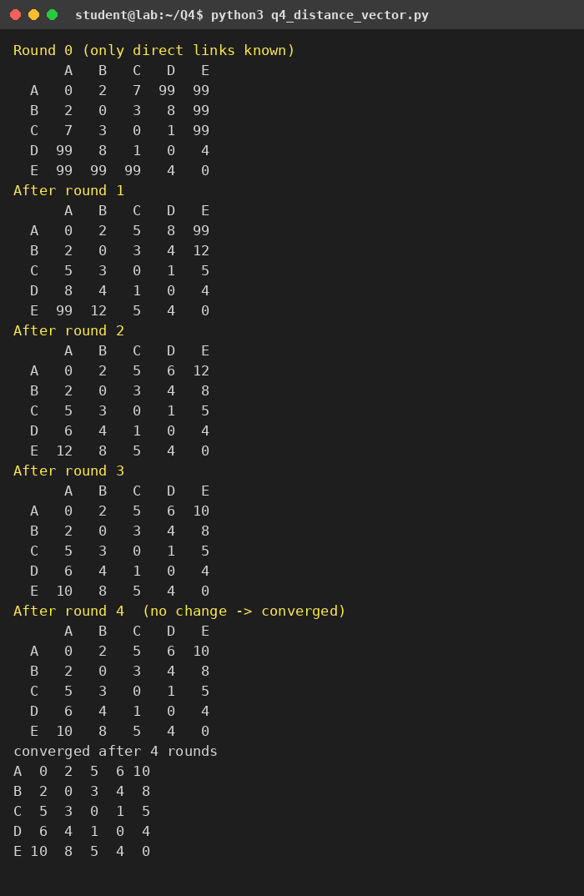
Figure 13: Output of q4_distance_vector.py: round-by-round tables and the final result (converged after 4 rounds)

C–D failed (cost set to 99) and rerun
With C–D removed the cheapest route between C and D is C → B → D = 3 + 8 = 11, and every distance that used the C–D link increases (see the tables). The network again converges, after 3 rounds.
Table 17: After C–D failure, round 1
 | A | B | C | D | E
A | 0 | 2 | 5 | 10 | ∞ (99)
B | 2 | 0 | 3 | 8 | 12
C | 5 | 3 | 0 | 11 | ∞ (99)
D | 10 | 8 | 11 | 0 | 4
E | ∞ (99) | 12 | ∞ (99) | 4 | 0

Table 18: After C–D failure, round 2
 | A | B | C | D | E
A | 0 | 2 | 5 | 10 | 14
B | 2 | 0 | 3 | 8 | 12
C | 5 | 3 | 0 | 11 | 15
D | 10 | 8 | 11 | 0 | 4
E | 14 | 12 | 15 | 4 | 0

Table 19: After C–D failure, round 3 (no change – converged)
 | A | B | C | D | E
A | 0 | 2 | 5 | 10 | 14
B | 2 | 0 | 3 | 8 | 12
C | 5 | 3 | 0 | 11 | 15
D | 10 | 8 | 11 | 0 | 4
E | 14 | 12 | 15 | 4 | 0

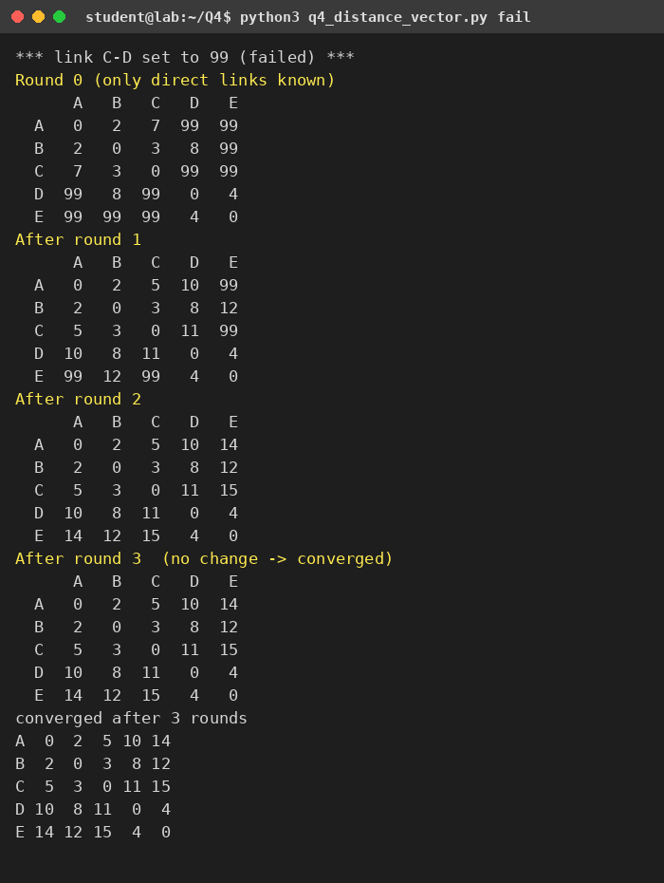
Figure 14: Output of `python3 q4_distance_vector.py fail`
Table 20: Effect of the C–D failure on selected distances
Pair | Before (C–D up) | After (C–D = 99) | Path now used
C → D | 1 | 11 | C–B–D
A → D | 6 | 10 | A–B–D
A → E | 10 | 14 | A–B–D–E
C → E | 5 | 15 | C–B–D–E

3. Count to infinity and poison reverse (X – Y – Z)
X–Y and Y–Z each cost 1. Before the failure X reaches Z through Y at cost 2 and Y reaches Z at cost 1. When the Y–Z link fails, Y knows it has lost its direct route but X still advertises “Z is 2 away”. Y cannot see that this route goes through Y itself, so it adopts it (1 + 2 = 3). Then Y advertises 3 to X, X (whose next hop is Y) updates to 4, and so on. RIP stops at infinity = 16.
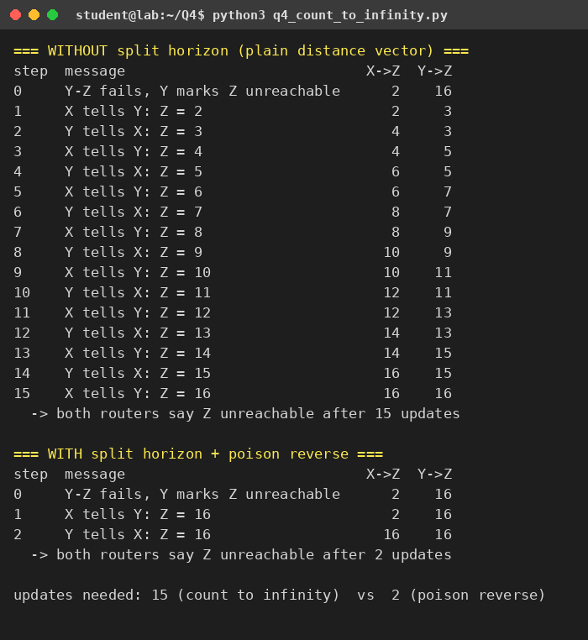
Figure 15: Output of q4_count_to_infinity.py – without and with poison reverse
Table 21: Count to infinity (assumption: X’s periodic update reaches Y first, then they alternate)
Step | Message | X → Z | Y → Z | Comment
0 | Y–Z link fails | 2 | ∞ | Y marks Z unreachable
1 | X tells Y: Z = 2 | 2 | 3 | Y believes X (it does not know X’s route goes through Y)
2 | Y tells X: Z = 3 | 4 | 3 | X’s next hop is Y, so X follows
3 | X tells Y: Z = 4 | 4 | 5 | distance grows by 2 every pair of updates
… | … | … | … | …
14 | Y tells X: Z = 15 | 16 | 15
15 | X tells Y: Z = 16 | 16 | 16 | both reach 16 = unreachable after 15 updates

While the distances climb, packets for Z bounce between X and Y until their TTL expires, wasting bandwidth, and convergence takes 15 update exchanges (about 15 × 30 s = 7.5 minutes with RIP’s periodic updates if no triggered updates are used).

How split horizon with poison reverse stops it
Split horizon: a router does not advertise a route back out of the interface from which it learned it. Poison reverse goes one step further: it advertises that route back with an infinite metric (16). Here X learned Z from Y, so X tells Y “Z = 16”. Y therefore never adopts X’s old route; Y keeps Z unreachable and tells X “Z = 16”, and X marks Z unreachable. Both routers agree after 2 updates instead of 15, and no loop forms. Poison reverse still fails for loops that involve three or more routers; hold-down timers and triggered updates are needed for those.

4. RIP in Packet Tracer
! Packet Tracer - RIP v2 on a 3-router version of the network (repeat per router)
! Example R1 (LAN 192.168.10.0/24, links 10.0.0.0/30 and 10.0.0.4/30)
enable
configure terminal
router rip
version 2
no auto-summary
network 192.168.10.0
network 10.0.0.0
passive-interface GigabitEthernet0/0
end
! test: show ip route rip | show ip protocols | debug ip rip
! failure test: shutdown the link on one router (interface Serial0/0/0 / shutdown) and watch show ip route
! (RIP timers: update 30 s, invalid 180 s, flush 240 s; hold-down 180 s. Triggered update speeds recovery.)

Expected observation: after router rip is enabled on all routers, show ip route rip lists the remote networks marked R with the metric in hops. When a link is shut down, the neighbour sees the interface go down and sends a triggered update with metric 16; show ip route then shows the route as possibly down or replaced through another path. Without a redundant path the route is removed after the invalid timer (180 s) and flush timer (240 s); with a redundant path the backup appears within a few seconds to a minute.

5. Alternative Concept Analysis – link-state routing
In link-state routing each router floods a link-state advertisement (LSA) describing its own links; every router then builds the same map and runs Dijkstra locally. After C–D fails, only C and D originate new LSAs, which are flooded over the remaining links.
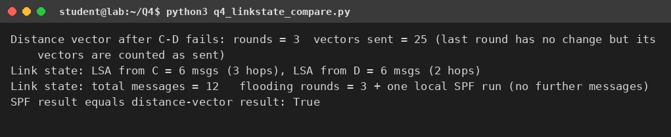
Figure 16: Output of q4_linkstate_compare.py
Table 22: Distance vector versus link state after the C–D failure (5 routers, 5 remaining links)
Measure | Distance vector (RIP-style) | Link state (OSPF-style)
Messages sent until all routers are correct | 25 vectors (every router that changed re-sends its whole vector to all neighbours) | 12 LSA copies (6 for C’s LSA, 6 for D’s LSA)
Rounds before every router has a correct route | 3 rounds (the simulation restarts from direct-link knowledge) | 3 flooding hops, then one local SPF run; no further messages
Message size | Whole distance vector (N entries) | One LSA with the router’s own links
Loop risk | Count to infinity, slow convergence with other failures | Loop-free after SPF; routers always agree on the map
Cost | Low CPU and memory | Higher CPU and memory (database + SPF)

Judgement: in this small network both methods reach correct routes in about three rounds, but link state needs less than half the messages (12 against 25) and cannot count to infinity; distance vector is acceptable only for small, stable networks where its simplicity matters. The message counts depend on the stated assumptions (restart from direct links for distance vector, flooding with duplicate suppression for link state); the difference grows with the size of the network, because a vector carries N entries while an LSA carries one router’s links.

Q5 – Why Does OSPF Treat 1 Gbps and 10 Gbps the Same? 6 Marks
Ans:

1. OSPF costs and the problem
OSPF cost = reference bandwidth ÷ interface bandwidth, rounded down, with a minimum of 1. With the default reference of 100 Mbps:
Table 23: OSPF cost per link speed for three reference bandwidths
Link speed | Reference 100 Mbps (default) | Reference 10 Gbps | Reference 100 Gbps (chosen)
10 Mbps | 10 | 1000 | 10000
100 Mbps | 1 | 100 | 1000
1 Gbps | 0.1 → 1 | 10 | 100
10 Gbps | 0.01 → 1 | 1 | 10
100 Gbps | 0.001 → 1 | 0.1 → 1 | 1

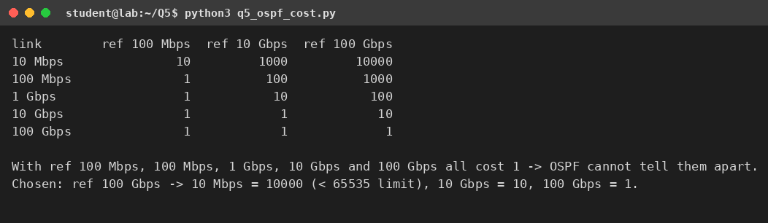
Figure 17: Output of q5_ospf_cost.py
The problem: every link of 100 Mbps and faster costs 1, so OSPF cannot tell 100 Mbps, 1 Gbps and 10 Gbps apart and simply minimises the number of hops. In the network below, R1 → R6 over two 1 Gbps hops (cost 2) beats three 10 Gbps hops (cost 3), so the traffic uses the slower path; had the two paths cost the same, OSPF would split the traffic equally (ECMP) and the 1 Gbps link would saturate at 1 Gbps of load while the 10 Gbps path stayed about 90 % idle.

2. New reference bandwidth
Choice: 100 Gbps (`auto-cost reference-bandwidth 100000`, the value is in Mbps). The reference must be at least as large as the fastest link so that no link is rounded down to cost 1 unintentionally, and the slowest link must still fit in OSPF’s 16-bit interface cost (max 65,535): 10 Mbps → 10,000 is safe. A 10 Gbps reference would still make 10 Gbps and 100 Gbps links identical. The value must be the same on every router, otherwise the routers compute inconsistent costs and can create suboptimal or looping paths.

3. Dijkstra by hand from R1 (6-router network of my design)
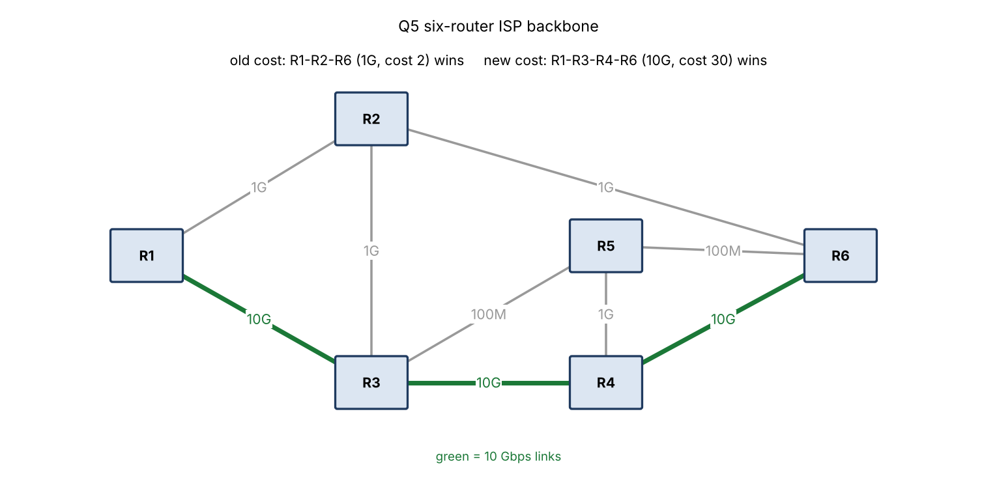
Figure 18: Designed network: green = 10 Gbps; the 100 Mbps links are R3–R5 and R5–R6
Table 24: Link costs (reference 100 Gbps)
Link | R1–R2 | R2–R6 | R1–R3 | R3–R4 | R4–R6, R2–R3, R4–R5, R3–R5, R5–R6
Speed | 1G | 1G | 10G | 10G | 10G, 1G, 1G, 100M, 100M
Cost | 100 | 100 | 10 | 10 | 10, 100, 100, 1000, 1000

Table 25: Dijkstra’s algorithm from R1 (tentative cost to each router after every step)
Step | Router fixed | R2 | R3 | R4 | R5 | R6
1 | R1 (0) | 100 | 10 | ∞ | ∞ | ∞
2 | R3 (10) | 100 (110 is worse) | 10 ✓ | 20 | 1010 | ∞
3 | R4 (20) | 100 | – | 20 ✓ | 120 (via R4) | 30
4 | R6 (30) | 100 (130 is worse) | – | – | 120 | 30 ✓
5 | R2 (100) | 100 ✓ | – | – | 120 | –
6 | R5 (120) | – | – | – | 120 ✓ | –

Table 26: Shortest-path tree from R1
Destination | Cost | Path | Old result (reference 100 Mbps)
R2 | 100 | R1–R2 | R1–R2 (cost 1)
R3 | 10 | R1–R3 | R1–R3 (cost 1)
R4 | 20 | R1–R3–R4 | R1–R3–R4 (cost 2)
R5 | 120 | R1–R3–R4–R5 | R1–R3–R5 (cost 2, via a 100 Mbps link)
R6 | 30 | R1–R3–R4–R6 (all 10 Gbps) | R1–R2–R6 (cost 2, 1 Gbps links)

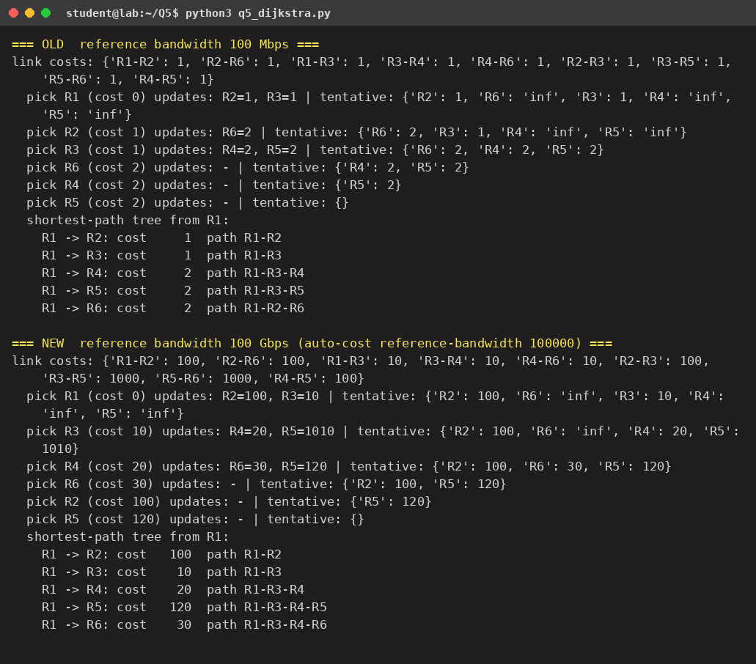
Figure 19: Output of q5_dijkstra.py: old costs, then new costs. The program’s results equal the hand calculation
With the new costs R1 → R6 is 100 + 100 = 200 on the 1 Gbps route but only 10 + 10 + 10 = 30 on the 10 Gbps route, so OSPF chooses R1–R3–R4–R6. R5 is also reached over the 1 Gbps link R4–R5 (cost 100) instead of the 100 Mbps link R3–R5 (cost 1000).

4. OSPF in Packet Tracer
! Packet Tracer - OSPF with a corrected reference bandwidth (repeat on every router, same value everywhere)
enable
configure terminal
router ospf 1
router-id 1.1.1.1
auto-cost reference-bandwidth 100000
network 10.0.13.0 0.0.0.3 area 0
network 10.0.12.0 0.0.0.3 area 0
passive-interface GigabitEthernet0/0
end
! the interface bandwidth must match the real speed, e.g. on Packet Tracer serial/ethernet links:
! interface GigabitEthernet0/1 / bandwidth 10000000 (kbps -> 10 Gbps)
! interface GigabitEthernet0/2 / bandwidth 1000000 (kbps -> 1 Gbps)
! or force a cost directly: ip ospf cost 10
! verify: show ip ospf interface brief | show ip route ospf | traceroute <R6 loopback>

Expected: before the change show ip route 10.6.6.6 (R6’s loopback) on R1 shows the path through R2 with metric 3 (two hops × 1 plus the loopback); after auto-cost reference-bandwidth 100000 on every router and correct interface bandwidths, the metric becomes about 31 and the next hop is R3 (R1–R3 is the 10 Gbps link). traceroute shows R1 → R3 → R4 → R6.

5. One OSPF area or several?
Decision: single area (area 0) for the 6-router network of this exercise, and a hierarchical design – area 0 as the backbone plus one area per region, with ABRs summarising – for the real state ISP.
- Single area works up to a few dozen routers: every router keeps the same link-state database and runs SPF on every change; with 6 routers this costs nothing and the configuration is the simplest.
- A state ISP has dozens to hundreds of routers and thousands of links and prefixes: in one area every flapping access link makes all routers rerun SPF, the database grows and convergence suffers. Multiple areas confine a flap to its region, shrink the database, and let area border routers send summary routes (e.g. one /16 per region) to the backbone.
- Trade-offs: multi-area needs careful addressing (regions must have contiguous, summarisable blocks, as in Q2), every area must connect to area 0, and ABRs become important failure points. Suboptimal inter-area routing can also occur because only summaries are exchanged.

6. Alternative Concept Analysis – EIGRP and IS-IS
Compare the 2-hop 1 Gbps path R1–R2–R6 with the 3-hop 10 Gbps path R1–R3–R4–R6. Classic EIGRP metric = 256 × (10⁷ ÷ lowest bandwidth in kbps + sum of delays in tens of µs); GigE and 10GigE interfaces both have a delay of 10 µs. IS-IS uses a default metric of 10 per link regardless of speed.
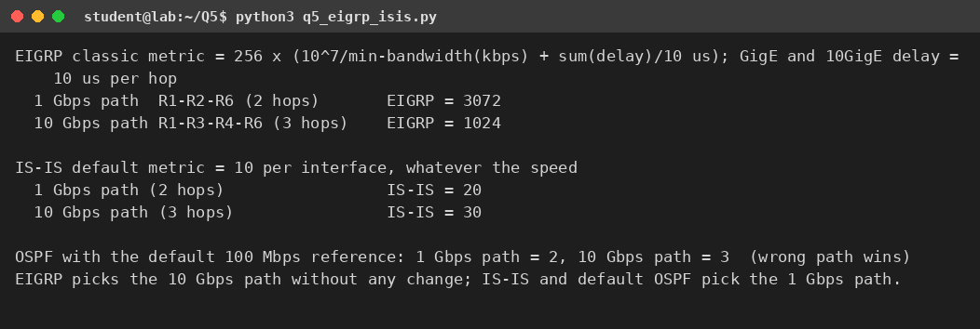
Figure 20: Output of q5_eigrp_isis.py
Table 27: Metrics of the two candidate paths
Protocol | 1 Gbps path (2 hops) | 10 Gbps path (3 hops) | Path chosen
OSPF, reference 100 Mbps | 2 | 3 | 1 Gbps path (wrong)
OSPF, reference 100 Gbps | 200 | 30 | 10 Gbps path
EIGRP (classic) | 256 × (10 + 2) = 3072 | 256 × (1 + 3) = 1024 | 10 Gbps path
IS-IS (default) | 20 | 30 | 1 Gbps path (wrong)

Decision: EIGRP avoids the problem without any change, because its metric uses the lowest bandwidth on the path (10⁷ ÷ 10⁶ = 10 for 1 Gbps, 10⁷ ÷ 10⁷ = 1 for 10 Gbps) and the delay. IS-IS has the same weakness as default OSPF and would need manual interface metrics. Two cautions: classic EIGRP’s bandwidth term saturates at 10 Gbps (a 100 Gbps link would again look the same, so “wide” metrics in named mode are needed for faster links) and EIGRP was proprietary (Cisco-only) before it was published as an informational RFC. For a multi-vendor ISP, fixing the OSPF reference bandwidth is the more portable solution; EIGRP is better only in an all-Cisco network.

Q6 – IPv6, ICMP, Multicast and SDN in a Smart City 5 Marks
Ans:
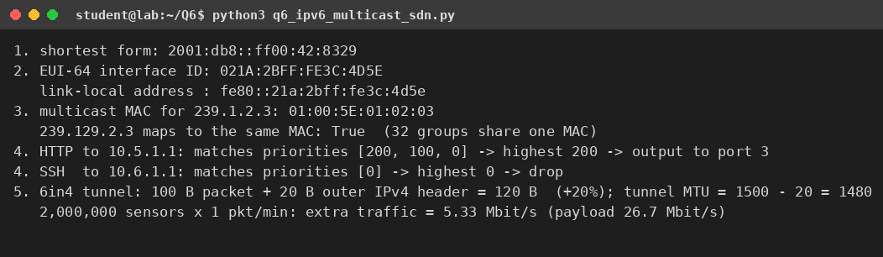
Figure 21: Output of q6_ipv6_multicast_sdn.py (all calculations of this question)

1. IPv6 shortest form
2001:0db8:0000:0000:0000:ff00:0042:8329 → drop the leading zeros of each group (2001:db8:0:0:0:ff00:42:8329) → replace the longest run of all-zero groups (the three groups 0:0:0) by :: → 2001:db8::ff00:42:8329. (:: may be used only once.)

2. EUI-64 interface identifier for MAC 00:1A:2B:3C:4D:5E
- Split the MAC in the middle: 00:1A:2B | 3C:4D:5E.
- Insert FF:FE between the halves: 00:1A:2B:FF:FE:3C:4D:5E.
- Flip the 7th bit (the universal/local bit) of the first byte: 00 = 00000000 → 00000010 = 02.
Interface identifier = 021A:2BFF:FE3C:4D5E; with the link-local prefix the sensor’s address is fe80::21a:2bff:fe3c:4d5e. (EUI-64 exposes the MAC address; for privacy, randomised identifiers are preferable for devices that move.)

3. How traceroute uses the TTL field and ICMP Time Exceeded
Every IP packet has a TTL (hop-limit in IPv6) that each router decrements by one; a router that decrements it to 0 discards the packet and sends an ICMP Time Exceeded message (type 11, code 0; in ICMPv6 type 3) to the source, with the router’s own address as the source of that message. Traceroute exploits this:
- It sends a probe with TTL = 1. The first router decrements it to 0, drops it and returns Time Exceeded – the source address reveals router 1, and the time to the reply is the round-trip time to it.
- It then sends probes with TTL = 2, 3, 4 … each probe travels one hop further, so each router on the path reveals itself in turn (normally three probes per TTL value).
- The final destination does not send Time Exceeded: it answers a UDP probe (sent to an unlikely high port) with ICMP Port Unreachable (type 3, code 3), or an ICMP echo probe (as used by Windows tracert) with an echo reply. This tells traceroute that the path is complete.
Routers that rate-limit or filter ICMP appear as * * *, and the path can differ between probes when the network load-balances.

4. Multicast MAC address for 239.1.2.3
The multicast MAC is 01:00:5E followed by the low-order 23 bits of the group address. 239.1.2.3: the 2nd octet 1 (the highest bit of that octet is dropped, leaving 7 bits: 0000001), 3rd octet 2, 4th octet 3 → 01:00:5E:01:02:03. Because only 23 of the 28 variable bits are copied, 32 different groups share each MAC address (for example 239.129.2.3 maps to the same MAC), so hosts still filter by the IP address.
Why one camera stream reaches several control rooms without being copied by the camera: the camera sends one packet stream to the group address 239.1.2.3. Control rooms join the group with IGMP (IPv4) or MLD (IPv6); multicast routing (PIM) builds a delivery tree from the camera to the members, and routers replicate the packet only where the tree branches. The camera’s uplink therefore carries one copy: with a 4 Mbit/s stream and 5 control rooms, unicast would need 5 × 4 = 20 Mbit/s on the camera’s link, multicast only 4 Mbit/s. On the last Ethernet segment, the switch delivers frames with MAC 01:00:5E:01:02:03 only to ports that joined (IGMP snooping).

5. OpenFlow rules
An OpenFlow switch compares each packet with the flow entries and applies the highest-priority entry that matches.
Table 28: Decision for the two packets
Packet | Entries that match | Highest priority | Action
HTTP to 10.5.1.1 (TCP 80) | 200 (dst 10.5.0.0/16) and 100 (TCP port 80) and 0 | 200 | Forwarded out of port 3 – it is not sent to the controller, although the priority-100 rule also matches
SSH to 10.6.1.1 (TCP 22) | only priority 0 (10.6.1.1 is outside 10.5.0.0/16; port 22 ≠ 80) | 0 (table-miss) | Dropped

Judgement on SDN. Benefits for the city: a central controller gives one place to define routing and security policy, can steer camera and emergency traffic around failures or congestion in seconds, and supports network virtualisation for different departments. Risks: the controller is a single point of failure and a high-value attack target (it needs clustering, authentication and encryption); sending the first packet of new flows to the controller adds delay and load (as the HTTP rule would, if it were the top priority); and the staff need new skills. Recommendation: adopt SDN in phases – first for the camera/backbone network where central traffic engineering gives the most benefit and the switches are replaced anyway, keep conventional routing as a fallback, and extend only after the controller is proven. The rule set above also shows why a final “drop” entry is safe but must be reviewed carefully: a mistake silently drops legitimate traffic.

6. Alternative Concept Analysis – IPv6, dual-stack or 6in4 tunnelling
Table 29: Three ways to introduce IPv6
Measure | Native IPv6 only | Dual-stack | 6in4 tunnelling over IPv4
Addresses for 2 million sensors | Ample: a /64 per subnet holds 2⁶⁴ hosts | IPv4 still needs NAT/private blocks for the sensors | IPv6 addresses but tunnelled over scarce IPv4 endpoints
Overhead | None | Two routing tables, double configuration and monitoring | +20 B per packet, MTU 1480, tunnel end-points
Compatibility | Breaks IPv4-only services and old devices | Everything works | Works where IPv4 only is available
Delay / reliability | Best path | Best path | Extra encapsulation, may follow a longer path; tunnel is a single point of failure
Security | One protocol to defend | Two attack surfaces | Tunnel can bypass firewalls
Cost | Lowest in the long term, high initial migration risk | Medium | Low initial cost, high operating cost

6in4 overhead: the tunnel adds a 20-byte outer IPv4 header (protocol 41) to each IPv6 packet. A 100-byte sensor packet becomes 120 bytes (+20 %), and the tunnel MTU is 1500 − 20 = 1480. If each of the 2 million sensors sends one 100-byte packet per minute (my assumption), the extra traffic is 2,000,000 × 20 B × 8 ÷ 60 s = 5.33 Mbit/s on top of 26.7 Mbit/s of payload – small for the city backbone but wasted on every sensor link that is metered or radio-based.
Decision: start with dual-stack in the city core and control rooms, make new sensors IPv6-only (native IPv6 on the access network), and use 6in4 tunnels only to reach remaining IPv4-only islands, retiring them over time. Dual-stack avoids breaking existing IPv4 services, while IPv6 for sensors avoids a NAT layer for 2 million devices.

Q7 – Find the Weak Point, Redesign and Validate 13 Marks
Ans:
Network selected: the college campus of Q2 (192.168.10.0/24, VLSM plan for Labs, Staff, Library and the WAN link, with the 60-host hostel added six months later). The redesign changes only the addressing and summarisation plan; no equipment is added (the same router, one switch and the same WAN link).

A. Identify the limitation (2 marks)
Evidence from Q2. (1) The VLSM plan uses 228 of the 256 addresses of the /24; the 28 that remain form only three small blocks (192.168.10.228/30, .232/29, .240/28; largest block 16 addresses). (2) The hostel needs a /26 = 64 addresses, so it does not fit; the total block space needed, 128 + 64 + 64 + 32 + 4 = 292, exceeds 256 – the /24 cannot be rearranged to fit. (3) Patching the hostel in from an unrelated block (e.g. 192.168.50.0/26) leaves it with 62 usable addresses for 60 hosts (3.3 % headroom) and gives the City router two routes to reach the campus instead of one, so the summary route found in Q2 no longer covers the whole campus.
Cause in the design: the addressing plan was sized to the day-one need (blocks rounded up to the next power of two, headroom 20 – 26 %) with no reserved growth space and no summarisable parent block. VLSM saved addresses but placed the free space at the end of the block in unusable fragments, and the choice of one /24 for everything forced growth to be satisfied by non-adjacent blocks. Equipment, link speed and routing protocol are not the limitation; the address plan is.

B. Define the design objective (2 marks)
The redesigned plan must meet all of these measurable targets:
Table 30: Design objectives and how they are measured
No. | Objective | Measure
O1 | The 60-host hostel is added with no renumbering of Labs, Staff, Library or the WAN link | Number of renumbered subnets = 0
O2 | Every LAN subnet keeps at least 20 % spare capacity (usable ÷ hosts needed − 1) | Headroom per subnet ≥ 20 %
O3 | The whole campus is reachable from the City router with one summary route | Routes on R2 for the campus = 1
O4 | At least a /26 (64 addresses) of uncommitted space remains for further growth | Free addresses in the campus block ≥ 64

C. Design the revised network (4 marks)
What changed. (1) The campus now owns the adjacent block 192.168.10.0/23 (192.168.10.0/24 + 192.168.11.0/24). (2) The four existing subnets keep their addresses (no renumbering). (3) The hostel gets a /25 = 192.168.11.0/25 (126 usable addresses for 60 hosts, 110 % headroom, enough for doubling). (4) 192.168.11.128/25 is reserved for future growth. (5) R2 holds one route, 192.168.10.0/23, instead of one route per subnet. (6) Each LAN is a VLAN on one switch trunked to R1 (router-on-a-stick), so no new router or switch is needed.
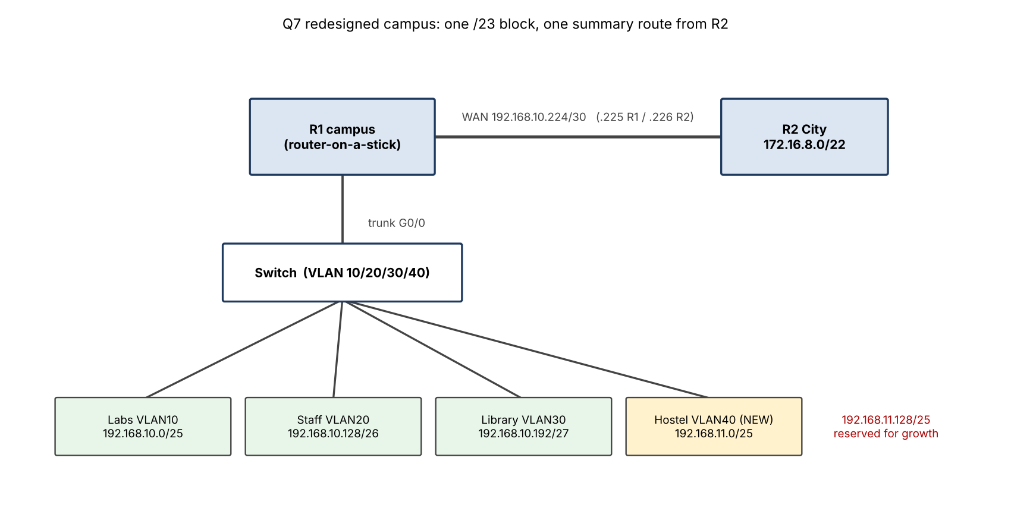
Figure 22: Topology of the redesigned campus (same devices as the original)
Table 31: Address table of the redesigned network
Network / device | Interface | Address | Mask | Gateway | VLAN
Labs (100 hosts) | R1 G0/0.10 | 192.168.10.1 | 255.255.255.128 (/25) | – | 10
Staff (50 hosts) | R1 G0/0.20 | 192.168.10.129 | 255.255.255.192 (/26) | – | 20
Library (25 hosts) | R1 G0/0.30 | 192.168.10.193 | 255.255.255.224 (/27) | – | 30
Hostel (60 hosts) NEW | R1 G0/0.40 | 192.168.11.1 | 255.255.255.128 (/25) | – | 40
WAN link | R1 S0/0/0 | 192.168.10.225 | 255.255.255.252 (/30) | – | –
WAN link | R2 S0/0/0 | 192.168.10.226 | 255.255.255.252 (/30) | – | –
Reserved | – | 192.168.11.128/25 | – | – | –
PC Labs / Staff / Library / Hostel | NIC | …10.2 / …10.130 / …10.194 / …11.2 | as subnet | …10.1 / .129 / .193 / 11.1 | 10/20/30/40

! Packet Tracer - campus router R1, router-on-a-stick for the REDESIGNED plan
enable
configure terminal
hostname R1
interface GigabitEthernet0/0
no shutdown
interface GigabitEthernet0/0.10
encapsulation dot1Q 10
! Labs
ip address 192.168.10.1 255.255.255.128
interface GigabitEthernet0/0.20
encapsulation dot1Q 20
! Staff
ip address 192.168.10.129 255.255.255.192
interface GigabitEthernet0/0.30
encapsulation dot1Q 30
! Library
ip address 192.168.10.193 255.255.255.224
interface GigabitEthernet0/0.40
encapsulation dot1Q 40
! Hostel (new /25)
ip address 192.168.11.1 255.255.255.128
interface Serial0/0/0
! WAN link to R2
ip address 192.168.10.225 255.255.255.252
clock rate 64000
no shutdown
exit
ip route 172.16.8.0 255.255.252.0 192.168.10.226
end
write memory
! R2 (City campus): interface S0/0/0 192.168.10.226 255.255.255.252 ; ONE route to the whole campus:
! ip route 192.168.10.0 255.255.254.0 192.168.10.225
! Switch: VLANs 10,20,30,40 ; Gi0/1 trunk to R1 ; access ports per VLAN

Trade-offs of the new design. (a) It uses 512 instead of 256 addresses – free if the block is private RFC 1918 space, but 2× the cost if public space is leased. (b) The hostel /25 leaves 66 usable addresses unused, deliberately, as growth headroom. (c) Router-on-a-stick sends all inter-VLAN traffic over one trunk link; with the present load this is acceptable but it would be the first bottleneck (a Layer-3 switch would remove it, but that is added equipment and was excluded). (d) One summary route hides the internal structure from R2: a failure of one subnet is no longer visible to the City router.

D. Predict before implementing (1 mark)
Prediction (written before running the tests): with the same tests, the redesign will leave connectivity unchanged (all pings succeed in both versions) but improve the measured values as follows: hostel headroom from 3.3 % to 110 % (O2), routes on R2 from 2 to 1 (O3), uncommitted campus space from 28 to 156 addresses (O4), with 0 subnets renumbered in both (O1). The measure I expect to improve most is routing-table size and growth headroom; throughput and delay should not change because the same links and devices are used.

E. Implement and validate (2 marks)
The same five tests are applied to both versions: T1 no overlapping subnets; T2 headroom ≥ 20 %; T3 routes needed on R2; T4 uncommitted space in the campus block; T5 renumbered subnets. The Python program checks the address plans with the ipaddress module; the Packet Tracer tests below apply the same plans to a running network.
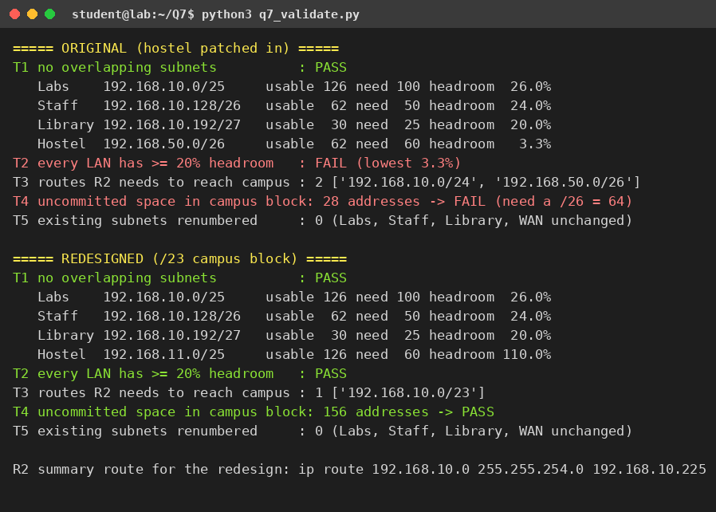
Figure 23: Output of q7_validate.py – original plan (hostel patched in) and redesigned plan
Table 32: Original → Redesigned (same tests)
Test | Original | Redesigned | Objective met?
T1 overlaps | none | none | both valid
T2 lowest headroom | 3.3 % (hostel) | 20 % (Library); hostel 110 % | Redesign passes O2
T3 routes on R2 | 2 | 1 | Redesign passes O3
T4 uncommitted space | 28 addresses | 156 addresses | Redesign passes O4
T5 subnets renumbered | 0 | 0 | Both meet O1

Packet Tracer tests (to run on both versions; expected results shown):
Table 33: Packet Tracer test plan with the expected results
Test | Original (hostel 192.168.50.0/26) | Redesigned (hostel 192.168.11.0/25)
Ping Hostel PC → Labs PC | Success | Success
Ping Hostel PC → City PC (172.16.8.x) | Success | Success
show ip route on R2 – campus routes | 2 static routes (/24 and /26) | 1 static route 192.168.10.0/23
show ip interface brief on R1 | interface for the extra block needed | sub-interface G0/0.40 only
Free addresses: ping a new host 192.168.11.200 added later | not possible (no space) | Success – inside the reserved /25

F. Defend the final design (2 marks)
- Objective achieved? Yes for all four measures: no subnet was renumbered (O1), all LANs have ≥ 20 % headroom (O2, lowest 20 % for the Library, hostel 110 %), the campus is one route (O3: 2 → 1) and 156 addresses are uncommitted (O4: 28 → 156). The addresses were validated by program; the Packet Tracer runs must confirm that connectivity is the same.
- New costs: double the private address space; 66 unused hostel addresses; a coarser summary that hides single-subnet failures from R2; one trunk that carries all inter-VLAN traffic; more planning discipline (the reserved /25 must really stay reserved).
- Where the original may still be preferable: if the address block is public and expensive, a small stable campus where the hostel will never grow beyond 60 hosts, or when only the smallest possible change is allowed – then the minimal fix of Q2 (hostel on a /26 in 192.168.11.0/24, also summarised by 192.168.10.0/23) meets the need at lower cost, with a hostel headroom of only 3.3 %.
- Judgement: the limitation was in the address plan, and changing the plan (not adding equipment) removed it. For a growing campus the redesign is better; the original is adequate only while growth is ruled out. The real Packet Tracer evidence should be attached before the report is submitted.

